EKA Mobility unveils EKA K1.5, India’s first 1.5-tonne electric LCV range

§ Launched at a very competitive starting price range of INR 13.9 lakhs* (ex-showroom), EKA K1.5 offers the highest payload capacity and lowest TCO in its Segment in the industry
§ With multiple variants, EKA K1.5 can be customized for more than 8 applications, making it the most versatile electric LCV range in its segment
§ Zero emissions, large battery capacity, and multiple use cycles per day make EKA K1.5 the most sustainable & profitable logistics LCV solution, completely designed & made in India
§ EKA K1.5 range is built on 300 volts electrical system architecture offering industry-leading peak power of 60kW along with efficient Fast Charge capabilities

New Delhi, Thursday, 2nd February 2024 — EKA, a leading player in the electric mobility sector with Mitsui Co., Ltd. (Japan) & VDL Groep (Netherlands) as equity partners, is set to revolutionize the commercial vehicle landscape with the launch of their highly anticipated 1.5 tonne electric Light Commercial Vehicles (LCVs). The grand unveiling took place at the prestigious Bharat Mobility Global Expo, where EKA Mobility showcased its commitment to sustainable and profitable transportation solutions.

EKA Mobility's 1.5-tonne electric LCVs are designed to meet the evolving needs of the modern logistics and transportation industry. With a focus on environment-conscious mobility, these electric LCVs promise to deliver exceptional performance, reduced operational costs, and a lower environmental footprint. The company also showcased its 9-meter electric bus, EKA 9 Staff Bus, India’s most advanced electric bus, designed and manufactured completely in India, at the expo.

Speaking at the launch, Dr. Sudhir Mehta, Founder & Chairman of EKA Mobility highlighted, “Our electric LCVs represent a significant step forward in the evolution of commercial transportation globally. We are confident that these vehicles will not only meet the demands of the industry but will also set new standards for sustainability and performance. Our vision is to become a global volume leader in Commercial Electric Vehicles. We have the strongest IP creation in the Indian EV industry, best-in-class Total Cost of Operation (TCO) offering, and completely indigenous and industry-leading software. We are proud to be the only EV company to have two leading global conglomerates as our partners, and we look forward to changing the commercial mobility landscape with sustainable and profitable solutions.”

EKA’s electric LCVs are designed for a wide range of applications, showcasing EKA Mobility's commitment to versatility. The vehicles can be customized for various purposes, making them ideal for last-mile delivery, e-commerce logistics, temperature-sensitive shipments, and more. EKA K1.5 range is built on 300 volts electrical system architecture offering the highest ever peak power of 60kW in the industry, with best-in-class vehicle performance. The vehicle and battery have a best-in-class warranty for worry-free usage. The company is currently offering EKA K1.5 in the following applications, with load body customizations suiting customer requirements:

§ Aluminium Container Body
▪ Side Open Aluminium Container Body
▪ Ms Container Body
▪ Open Top Container Body / Raised Load Body
▪ Half Load Body For Market Loads
▪ Eutectic Container For Cold Chain Applications
▪ Insulated Box Container Body
▪ Garbage Collector Body

One of EKA Mobility's standout features is its emphasis on indigenous software development. Unlike many competitors that rely on third-party solutions or central databases hosted elsewhere, EKA has invested significantly in creating its software ecosystem tailored to the unique needs of the vehicles and customers. This not only allows for greater customization and optimization but also ensures a higher level of security and reliability. The proprietary software not only powers the vehicles but also enables seamless connectivity, providing users with advanced features and a futuristic driving experience.

At the expo, the company is displaying its delivery van application for efficient and environmentally friendly urban logistics, and its innovative eutectic van showcasing EKA Mobility's dedication to exploring advanced technologies and solutions for temperature-sensitive cargo transportation. Earlier this year, EKA announced a partnership with Mitsui & Co., Ltd. (Japan) and VDL Groep (Netherlands) with a joint investment of over USD 100 million (~ INR 850 crores) in phases, to position India as the global manufacturing & sourcing hub for electric vehicles. Recently, the company also announced its collaboration with GreenCell Mobility to supply them with 1000 intercity electric buses in 12-meter and 13.5-meter categories, in the next few years.

EKA Mobility is one of the commercial vehicle manufacturers approved under the Champion OEM Scheme & EV component manufacturing scheme of the Government of India’s Auto PLI policy. EKA is one of the only Indian companies offering end-to-end design, manufacturing & technology of electric new energy commercial vehicles from scratch in India. The company has set up a state-of-the-art research, development, engineering & innovation center in Pune, Maharashtra, and has significantly grown its order book, with more than 700 electric buses and 5000+ electric light commercial vehicle orders in the pipeline. All these vehicles will be completely designed & manufactured in India, at EKA’s proposed & existing state-of-the-art manufacturing facilities in Madhya Pradesh and Maharashtra.

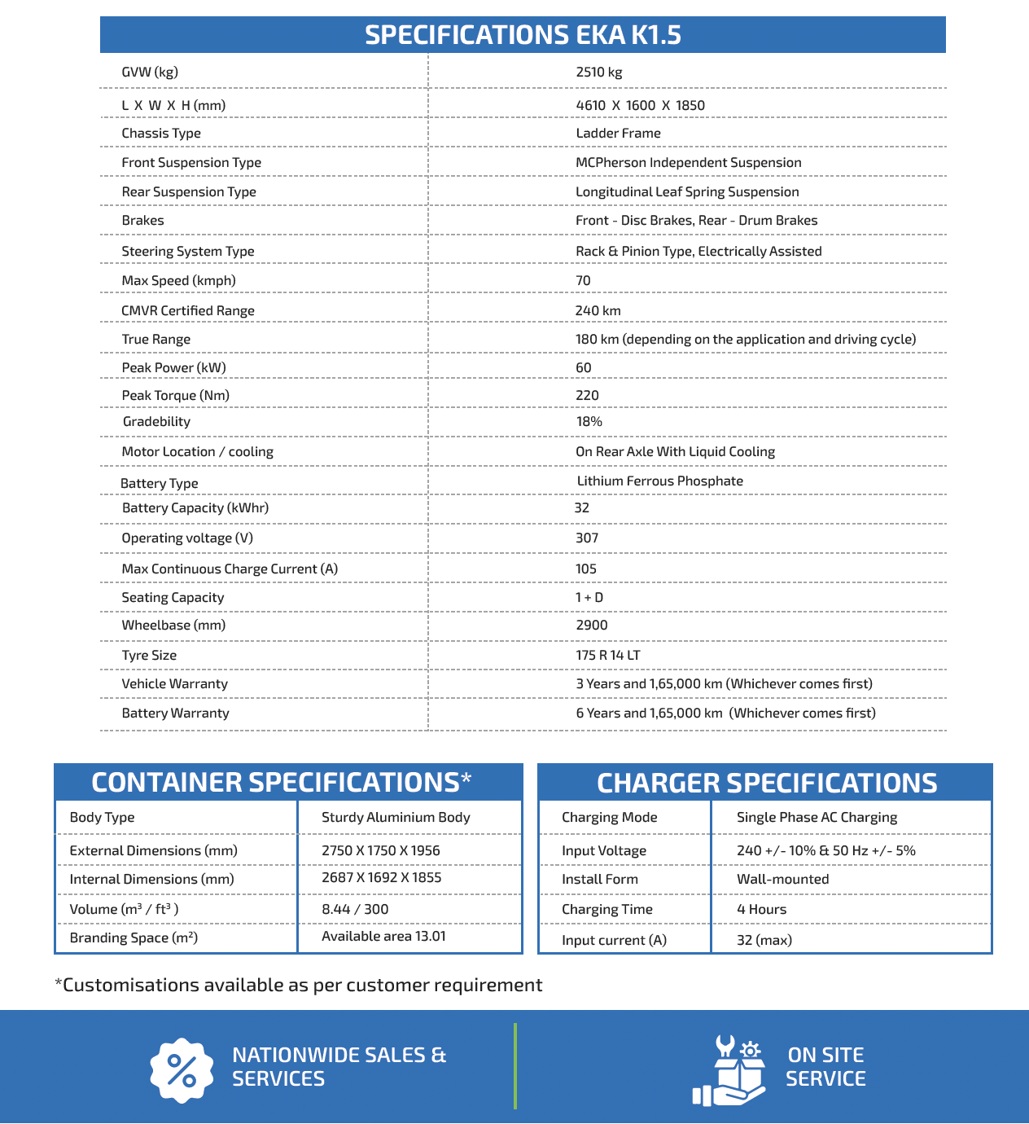

About EKA:
EKA, with Mitsui Co., Ltd. (Japan) & VDL Groep (Netherlands) as equity partners, is an automotive & technology company creating a new global CV electric mobility paradigm. EKA’s vision is to lead the world to a sustainable future by creating an ecosystem for Environment Conscious Mobility. With an industry-leading team, cutting-edge technology, modular designs, and lean manufacturing processes, EKA’s mission is to bring reliable and efficient mobility solutions to the masses. EKA’s sharable technologies and low-investment production processes enable the lowest TCO and democratize electric vehicles for mass adaptation.

To know more about the company, kindly visit:
https://ekamobility.com
For media-related queries, contact:
harshita.s@ekamobility.com | +91-70301-52828

